The 11th International Symposium on Measurement Techniques for Multiphase Flow (ISMTMF’19)
3 - 7 November 2019, Zhenjiang

Registration Form*
(Please type. Each registrant should submit one form. Photocopy is accepted.)

Name: (Prof. / Dr. / Mr. / Ms. ) _______________________________________________________________________
delete whichever inappropriate (Family Name) (Other Name)

Affiliation: _____________________________________________________________________________________________

Address: _____________________________________________________________________________________________

Tel: ___________________________________________ Email: _______________________________________________

Name of Accompanying Person (if any): ______________________________________________________________

Registration Fees (Please check )

 | Early Registration  (By 15 September 2019) | Standard Registration  (after 15 September 2019) |  | Registration On-Site
- Regular♠ | 390 USD / 2800 RMB | 500 USD / 3500 RMB |  | 550 USD / 3850 RMB
- Student♠ | 290 USD / 2000 RMB | 350 USD / 2500 RMB |  | 400 USD / 2800 RMB
- Spouse Registration♥ | 150 USD / 1000 RMB
 |  |  | Total: _______________________

♠ The regular and student registration fee includes plenary and parallel sessions, conference proceedings, meals, coffee breaks and social programme.
♥ The Spouse registration fee includes meals, coffee breaks and social programme.
All participants should register for the Symposium using Registration Form and pay Registration Fee as shown above. Please note: at least one registration is required for each abstract. If a participant does not register and does not pay Registration Fee, the presentation will be removed from the Symposium program and the abstract will not be published.

Payment (Please pay to Jiangsu University)
Note that: for Early and Standard Registrations, bank transfer only.
(1) If you make the payment inside China, please follow this procedure:
户名：江苏大学
账号：1104080509000000190
开户行：镇江工行江苏大学支行

(2) If you make the payment outside China, please follow this procedure:
Account name: JIANGSU UNIVERSITY
Bank name: BANK OF CHINA DING MAO QIAO SUB-BRANCH ZHENJIANG
Bank branch address: THE SEVEN WAY DINGMAO ECONOMIC DEVELOPMENT REGION ZHENJIANG JIANGSU CHINA
SWIFT code: BKCHCNBJ95D
Account number: For US dollar 515758226635;

When you transfer the registration fee, you have to leave a note to us as follows:
ISMTMF2019, your full name. Otherwise, we cannot make sure if you make the payment successfully. Besides, when you check in at the registration desk in Zhenjiang on 3rd November, you will be required to show us the certificate of payment, e.g., bank receipt.

If you would like to book the conference hotel with special discount for all participants, please fill below form and return it together with the registration form to Conference Secretariat by e-mail: ismtmf@ujs.edu.cn

*国内参会者可使用中文填写该表格，但仍建议尽量使用英文填写。
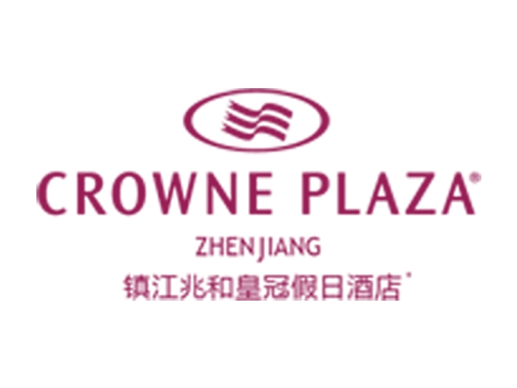
Reservation Order* 预订单

Guest Name(s) /客人姓名：
Company / 单位：
Telephone No / 电话号码：
Email /邮件地址：

Thank you for your recent inquiry with regards of the accommodation at Crowne Plaza Zhenjiang. We are pleased to confirm your reservation as follow:
十分感谢您对镇江兆和皇冠假日酒店的支持，我们很荣幸为阁下确认房间预订信息：

Arrival Date  到店日期 | Departure Date  离店日期 | Room Type ♠  房型类型 ♥ | Number of Room(s)  房间数量 | Number of Adult/Child  客人数量

♠Room Type: Double Beds room (about 100 rooms available) or Single Bed room (about 100 rooms available). Special rate at 450RMB/night, with 1-2 Breakfasts. The above daily rates are including 10% service charge and 6% VAT.
♥房间类型：大床房或者标准间, 各有约一百间可供预定。通过组委会预定可享受450元/晚的协议价格。该价格含1-2份早餐，并已包含服务费及相关税费。

*国内参会者可直接使用中文填写该表格。

No27 Changjiang Road, Zhenjiang, Jiangsu Province 212001,P.R.China 镇江市长江路27号 212001

The 11th International Symposium on Measurement Techniques for Multiphase Flow (ISMTMF’19)
3 - 7 November 2019, Zhenjiang

Invitation Letter Request Form for International Participants*
(Please type. Each invitation letter requested person should submit one form. Photocopy is accepted.)

Name: (Prof. / Dr. / Mr. / Ms. ) _______________________________________________________________________
delete whichever inappropriate (Family Name) (Other Name)

Date of Birth (YYYY/MM/DD): ___________________________ Gender: ___________________________________

Nationality: ______________________________________ Passport No.: ___________________________________

Date of issue on your passport (YYYY/MM/DD): _______________________________________________________

Date of expire on your passport (YYYY/MM/DD): _____________________________________________________

Affiliation: _____________________________________________________________________________________________

Address: _____________________________________________________________________________________________

Tel: ___________________________________________ Email: _______________________________________________

- All international participants are responsible for the application of necessary traveling documents to China. Please consult your local Chinese Embassy or Consulate.
- We would only send the invitation letter to whom is an author of an accepted abstract and/or paper.
- If you would like to receive an invitation letter, please fill above form and return it to Conference Secretariat by e-mail: ismtmf@ujs.edu.cn

*国内参会者请不要填写该表格。

